**Ideation Phase**

**Define the Problem Statements**

|  |  |
| --- | --- |
| Date | 30 Aug 2022 |
| Team ID | PNT2022TMID15389 |
| Project Name | Project – A Novel method for handwritten  digit recognition system |
| Maximum Marks | 2 Marks |

**Customer Problem Statement Template:**

Handwriting recognition has been the main subject of research for almost the last forty years. This research work analyzes the behaviour of classification techniques (CNN) in a large handwriting dataset (MNIST) to predict a digit. Machine-learning techniques, particularly when applied to Neural Networks like CNN or ANN, have played an increasingly important role in the design of these recognition systems. Several methods have been developed in handwritten digit recognition and these methods have been classified into categories: knowledge based methods, feature-based methods, template-based methods and appearance-based methods. Errors in Digit recognition cause severe problems like digits written on a bank cheque if recognized erroneously could result in unfortunate consequences.

The goal of our work is to create a model that will be able to recognize and classify the handwritten digits from images by using concepts of Convolution Neural Network. Though the goal of our research is to create a model for digit recognition and classification, it can also be extended to letters and an individual’s handwriting. The major goal of the proposed system is understanding Convolutional Neural Network, and applying it to the handwritten digit recognition system by working on the MNIST dataset. There have already been significant advancements in this area of research previously. We have tried to form a model around the Conventional Neural Network with MNIST as our dataset so that the model has high accuracy and has been trained and tested on a large dataset. We shall also consider developing a robust test harness for estimating the performance of the model and then exploring improvements to the model. With high accuracy rates, the model can solve a lot of reallife problems.

**Example:**

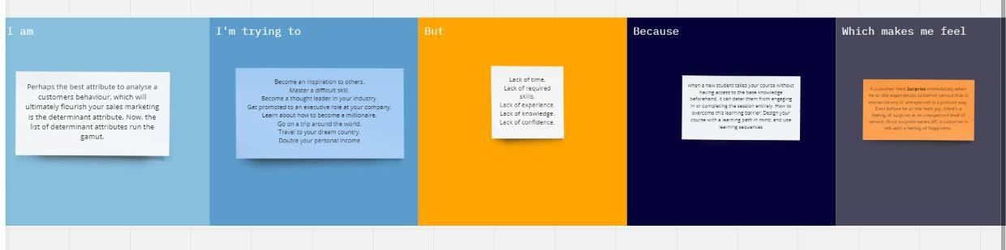

Reference: <https://miro.com/welcomeonboard/dlVxWjZWaUN5eHhEVXh5MkNpMldZV3FKUEZKSnhBNG11bXhZb3g4bGhmNWZMOElVY1dWMDh1d1Y5RkdxZU9MWnwzNDU4NzY0NTM1ODExOTI5MzQxfDI=?share_link_id=13642599616>

|  |  |  |  |  |  |
| --- | --- | --- | --- | --- | --- |
| **Problem Statement (PS)** | **I am (Customer)** | **I’m trying to** | **But** | **Because** | **Which makes me feel** |
| PS-1 | Perhaps the best attribute to analyse a customers behaviour, which will ultimately flourish your sales marketing is the determinant attribute. Now, the list of determinant attributes run the gamut. | Become an inspiration to others.  Master a difficult skill.  Become a thought leader in your industry.  Get promoted to an executive role at your company.  Learn about how to become a millionaire. | * Not enough time. * Lack of recognition.   Poor communication skills.   * Lack of managerial involvement. * Lack of growth opportunities. | when a new student takes your course without having access to the base knowledge beforehand, it can deter them from engaging in or completing the session entirely. How to overcome this learning barrier: Design your course with a learning path in mind. | A customer feels **Surprise** immediately when he or she experiences customer service that is extraordinary or unexpected in a positive way. Even before help  or she feels joy, there's a feeling of surprise at an unexpected level of service. Once surprise wears off. |